Assignment 1



1. What is AJAX? Advantages of AJAX?

**AJAX** = **A**synchronous **J**avaScript **A**nd **X**ML.



AJAX is not a programming language.

AJAX just uses a combination of:

A browser built-in XMLHttpRequest object (to request data from a web server)



JavaScript and HTML DOM (to display or use the data)



Working of AJAX



Update a web page without reloading the page

Request data from a server - after the page has loaded

Receive data from a server - after the page has loaded

Send data to a server - in the background

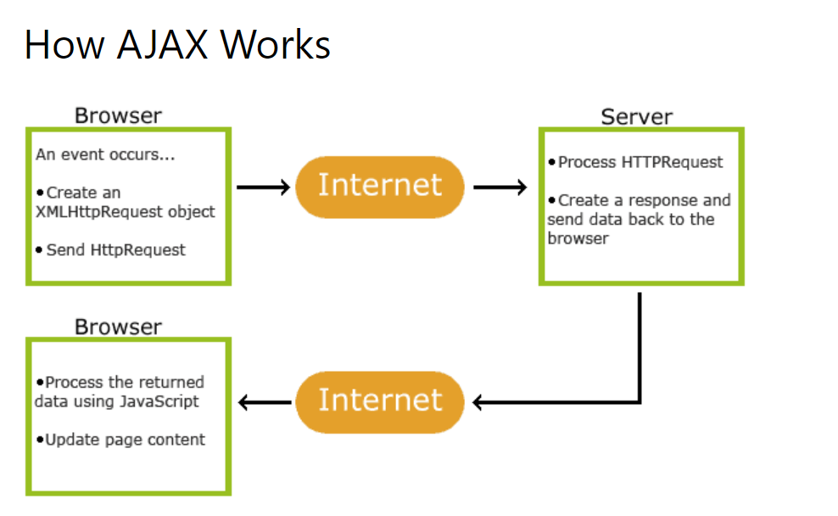



**Advantages:**

* Speed is enhanced as there is no need to reload the page again.
* AJAX make asynchronous calls to a web server, this means client browsers avoid waiting for all the data to arrive before starting of rendering.
* Form validation can be done successfully through it.
* Bandwidth utilization – It saves memory when the data is fetched from the same page.
* More interactive.

1. What is JSON? Why do we use JSON?

[JSON](https://en.wikipedia.org/wiki/JSON) is a data interchanging format that uses human-readable text to transmit data objects consisting of data structure and it’s the most widespread format for data serialization. Simply [JSON](https://en.wikipedia.org/wiki/JSON) is text, written with JavaScript object notation. **“JavaScript Object Notation”** is the full form of [JSON](https://en.wikipedia.org/wiki/JSON).

[**JSON**](https://en.wikipedia.org/wiki/JSON) is mainly intended for data interchanging among the applications. Parsing data from one application to another through [JSON](https://en.wikipedia.org/wiki/JSON) is so much easy because of its [language-independent](https://en.wikipedia.org/wiki/Language-independent_specification) data format. Almost every programming language has JSON support through official and 3rd party. Now, referencing my example, [JSON](https://en.wikipedia.org/wiki/JSON) can be used as a configuration or temporary data storing file also for any application. There is an important fact that [JSON](https://en.wikipedia.org/wiki/JSON) lacks [Abstract Data Type](https://en.wikipedia.org/wiki/Abstract_data_type) (ADT) feature because of its data serialization format which breaks the opacity of [ADT](https://en.wikipedia.org/wiki/Abstract_data_type) by potentially exposing private implementation details.

1. What is jQuery? Advantages of JQuery?

jQuery is an open-source JavaScript library that simplifies the interactions between an HTML/CSS document, or more precisely the Document Object Model (DOM), and JavaScript. Elaborating the terms, it simplifies HTML document traversing and manipulation, browser event handling, DOM animations, Ajax interactions, and cross-browser JavaScript development.

**Advantages:**

* Wide range of plug-ins that allows developers to create plug-ins on top of the JavaScript library.
* Large development community.
* It is a lot easier to use compared to standard javascript and other javascript libraries.
* It lets users develop Ajax templates with ease. Ajax enables a sleeker interface where actions can be performed on pages without requiring the entire page to be reloaded.
* Being Light weight and a powerful chaining capabilities makes it more strong.

1. What is No-Sql Database? Examples?

NoSQL is a type of database management system (DBMS) that is designed to handle and store large volumes of unstructured and semi-structured data. Unlike traditional relational databases that use tables with pre-defined schemas to store data, NoSQL databases use flexible data models that can adapt to changes in data structures and are capable of scaling horizontally to handle growing amounts of data.

The term NoSQL originally referred to “non-SQL” or “non-relational” databases, but the term has since evolved to mean “not only SQL,” as NoSQL databases have expanded to include a wide range of different database architectures and data models.

**Types of NoSQL database:** Types of NoSQL databases and the name of the databases system that falls in that category are:

1. **Graph Databases**: Examples – Amazon Neptune, Neo4j
2. **Key value store:** Examples – Memcached, Redis, Coherence
3. **Tabular:** Examples – Hbase, Big Table, Accumulo
4. **Document-based:** Examples – MongoDB, CouchDB, Cloudant
5. What is HTTPS Status Code? What is the meaning of 401,403,404.500 Status codes?

TTP Protocol is used everywhere from the server page to each service communication, deploying service to monitoring service. HTTP codes give an extension of[HTTP protocol](https://www.geeksforgeeks.org/http-full-form/) to debug network problems using curl, telnet able to check server availability, service responses

HTTP status code is used for search engine optimization of how your pages get indexed, as well as how search engines perceive the performance of your site.

### **Client Error Responses**

| **Message** | **Description** |
| --- | --- |
| 400 Bad Request | This response code indicates that the server detected a syntax error in the client’s request. |
| 401 Unauthorized | The service failed because of not give proper parameters like  username, password |
| 402 Payment Required | This code is not yet implemented in HTTP. |
| 403 Forbidden | The request was denied for a reason the server does not want to (or has no means to) indicate to the client. |
| 404 Not Found | The document at the specified URL does not exist. |

### **Server Error Responses**

| **Message** | **Description** |
| --- | --- |
| 500 Internal Server Error | This code indicates that a part of the server encountered a configuration error. |